Project

Game Design Document

Draft 1

By Caroline Percy &

Danial Hakim Nor Azman

5 / 10 / 2021

Alien Escape

Table of Contents

**1.** Overview 3

**1.** **The Elevator Pitch / High Concept** 3

**2.** **Theme, Setting and Genre** 3

**3.** **Player Experience Goals** 3

**4.** **View** 3

**5.** **Targeted platform(s)** 4

**6.** **Technical requirements(s)** 4

**2.** GamePlay 4

**1.** **The First Minute (60 seconds of play)** 4

**2.** **Game progression** 4

**3.** **Level progression** 5

**4.** **Objectives/Victory Conditions** 5

1. Overview
   1. **The Elevator Pitch / High Concept**

Alien Escape is a two-dimensional horror-style game where the player races to escape a space ship before they are found by the alien.

* 1. **Theme, Setting and Genre**

The game will be on an alien ship and it will be dark inside the ship.It will be a horror single player game.

* 1. **Player Experience Goals**

Player experience goals will be fear and tension, followed by relief - whether it's escaping the alien for a moment, or being scared by it.

* 1. **View**

The game will be a top down view game and the camera will be fixed in height.The camera will follow the player around, keeping the player in the middle of the screen at all times.

* 1. **Targeted platform(s)**

Windows 8 or later. 1024 x 800 resolution expected.

* 1. **Technical requirements(s)**

The hardware we will be using for this project is personal laptops and college computers.We will be using SFML and visual studio as our software to develop the game.As for now, we are not using any game engine. The game is a single player offline horror game so it does not have any network requirement.

1. Gameplay
   1. **The First Minute (60 seconds of play)**

After a title screen, the player is presented with a top down view of a man - the player character - in a small, dark room. The player is show a text saying “press ‘F’ to turn on your light.”. When the player presses F, a 45 degree cone appears in front of the man, starting from him and expanding out. It will change angle as the player moves the mouse around.

The player is shown a text saying “Use ‘WASD’ to move.” The player moves around, and explores the starting room. They find a locked door and a dead body. The player is shown the left mouse button when they walk over to the corpse, which allows them to investigate and pick up items. They find a key on the body, which fits the locked door.

Once the door is opened, the player moves around the first ship, which has two locked doors leading to different ships. The player will be told to “M - map”

The player opened the map, and it shows the four ships total in the game, arranged like corners of a square, with pathways between them. It also shows the mission ‘Get to the next ship.’ In the top right. The player closes the map after, and looks around the spaceship they’re on.

They find a book, a noisemaker, and the scanner. They use the book to learn the code ‘4923’ that will unlock a door, and uses the scanner. The scanner causes the screen to go green, open the map, and show several small yellow dots, one that has started moving in the player’s direction.

The player closes the scanner, and attempts to use the code on the door that’s going away from the moving scanner dot. The player succeeds the Quick Time Event to open the door, and heads on through.

* 1. **Game progression**

1. The player will be given certain tasks to do and as the player will get keys or items that allow them to go to the next area. The player can always go back to the areas they have unlocked to hide or to find other items later on.
2. The tasks will be harder as the player progresses. At the start of the game, the task will be as simple as picking up the item in this room, then grow to looking for parts to assemble the item in order to use it. The alien will also be more sensitive to sounds and will appear more.
3. The goal for the player is to escape the ship, the reward that will be given out is the item that the player gets to use after finishing their tasks.  
   1. **Level Progression**

level progression would be slowly but surely unlocking each room of the ship, and survive the alien patrolling around while doing so. The overall objective would be to escape the ship before the alien catches you, but the moment-to-moment objective would be to find the next key, or survive the alien stalking you nearby.

* 1. **Objectives/Victory Conditions**

The objective of the game is to stay hidden from the alien while finding a way to escape the ship. Player can move slower to have less noise or go faster with the risk of being found out by the alien. The choice is up to the player. The alien cannot be killed so player could either run away or hide. The victory condition is filled when the player has escaped the ship without being caught by the alien.

1. Features

The player can sneak, walk, and run, each having a different speed. 1m per second when walking, 1.5m when running, 0.75 when sneaking. Only running expends stamina, which lasts about 5 seconds. Stamina recovers in 3 seconds after that. The player can change between these movement modes instantly, but still stop altogether if they hit a wall.

The game has a hidden grid to help with item placement and collision. One square of the grid is the size of the player, and will contain the walls, floors, furniture, everything for the layout of the ship. The map square amount is 100x100, with a ship being a quarter of that.

A* pathfinding is being used for this project, to allow the alien move around the ships.

The player progresses through the game by doing the given missions. Said missions will be on the top right of the map when it’s open. The player fails their mission by getting caught and killed by the alien. The story of the game is the player is trapped on a ship with an alien, who has killed all other survivors. They must sneak past the alien, get the items necessary to unlock their way to the escape pod, and leave before getting caught. The player will have about missions before they win the game.

The alien is much faster then the player, moving 2 m per second when chasing the player, or 1m when patrolling. The alien has a 15 degrees vision cone with a length of 15, and a peripheral vision cone of 2m in a semi-circle in front of him. If the player vision cones, then the alien knows the player’s position. He can go through doors, and decides where to do by having a series of coordinates it can choose randomly. Once the coordinate is chosen, the alien will path find his way over to it. The alien only starts patrolling once the player finishes the tutorial, starts chasing when he knows the players position, and stops chasing when the alien reaches the player’s last known location it will enter a confused state. If it doesn’t spot the player after 5s of being in the confused state and looking around itself, it will go back to patrolling. It can go everywhere in the four ships.

For sounds, the alien will growl and heavy footsteps while searching, and shriek if it spots the player. The player will make noises by running, opening doors and using items like the scanner and noisemaker, which will beep and make a loud whirling noise respectively. Smoke bomb will also make noise, but not loud enough for the alien to hear it, but enough the player will. The environment will make creepy ambient noises, and opening doors will cause noise too. Each noise will be classified as one of four noise levels: One that can’t be heard by the alien, one where the sound can be heard only if you’re on the same ship, one where the sound can reach you if you’re on a nearby ship, and one where the sound can be heard from all around the station.

The player has an inventory. The inventory has four slots, one for each time of item. If the player picks up an item of the type they already have, it stacks in the inventory, with the exception of the book, which won’t be allowed to be picked up. The player can use WASD or the arrow keys to navigate the menu, and I to open and close the inventory menu. This will not pause the game, and the alien is still moving around. The inventory is slightly transparent. When this menu is open, the player cannot move on the map. They can equip the item they’ve selected by pressing E, then use it by closing the inventory menu. Hitting E again will cause the player to use that item.   
The four item types are noise maker, smoke bomb, scanner and book. Noise maker distracts the alien by the noise, the smoke bomb can block the alien from seeing the player and getting to them, the scanner shows the player where the alien is, though the alien will then know where the player is in return, and the book allows the player to progress and open new doors.

Two of the items can be thrown when the player equips then and hits E, specifically the Smoke Bomb and the noise maker. The book and scanner are merely used instead. The player can only have one item equipped at once. The noisemaker, smoke bomb, and book are all consumed on use. The player will be able to carry 3 of each kind of throwable item, with about 5 of each appearing on the map.

The UI of the game will have the player’s stamina in the bottom left, a small green bar that will go from green, to yellow, to red, to empty, as the stamina is used up. The colour will go in the opposite order when the stamina is refilling. The mission of the game will be on the map menu, and the mini-map of the game will be in the top right of the game. The player will be able to see the current spaceship they’re on. (the rooms layout, and which spaceships they connect to.) The map is opened with the M key, takes up the whole map, and shows where the player is on the map. It is slightly transparent so the player can see their surroundings, but they cannot move. The player can only see the details of the ship they’re currently on, the rest are in darkness. The four ships are connected to each other by pathways.

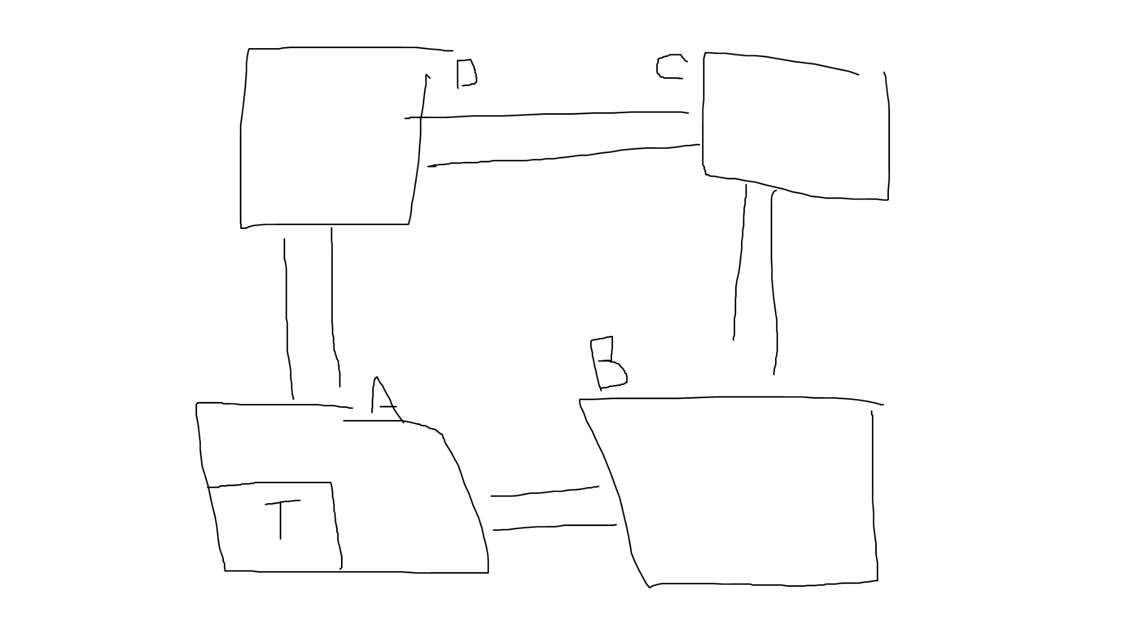

*A sketch of the idea for the map*

A menu appears at the start of the game, which allows the player to play, exit or character selection. The win screen appears when the player has escaped the ships, and the lose screen appears when they are killed by the alien.

From the settings menu, the player will able to choose between 3 styles of human. The first human will be the default, middle aged person who is a good all-rounder in the game. The next human will be a young adult, so they move faster, but they have 3 inventory slots instead of 4 to keep themselves light. Last is a older person, about mid-50s. They have a lot more experience, so they get longer time to input the numbers for the doors, and have a bigger flashlight to look around, but their age causes them to move slower.

The alien can also be different, but the player has no control over that. The alien also has 3 styles. One alien has extremely good vision, but is very loud, so it’s easy to tell when they’re nearby. One alien has immensely good hearing, but moves slowly, so it takes them time to react. The last is default, has an average style of movement, hearing and vision.

The ships the player will be traversing will be very dark, so they start with a flashlight to help them navigate. It isn’t a part of the inventory, the player has it automatically. It will light an area similar to a cone, with the top of the cone being the player. The height of the cone will be around 3m in front of the player, and 2m in width at the bottom of the cone. A few lights around the ships will also be on, but they will be sparse. The player can turn off & on the light with the F key. The reason the player would want to do this, is the alien would react if it could see your flashlight in front of it, and would know you’re nearby.

The player will have to travel between ships, but to do so, they must input the right numbers they find in the books. If the player takes too long putting in the code, or puts it in incorrectly, A loud alarm goes off, notifying the alien of where you are. If the player puts the code in correctly, no noise occurs, and the player can move to the next ship.

A particle system will be implemented for visual effects, such as from fire, the smoke of the smoke bomb, sparks from broken technology, and a small candlelight from the noisemaker. These particles will be visible despite the dark, though they won’t be able to see particles from adjacent rooms to their own.